To set up an Authorized User to view/pay your student account, click this link and follow the below instructions:

- Log in with your Doane credentials.

- If you, have not already set up your account with Nelnet, you will need to create your Nelnet account by entering the requested info. Then you will be able to set up Authorized Users by following the steps below.

- If you already have an account set up with Nelnet, you will be directed to your Nelnet account homepage.

- Select “Add an Authorized Party”. Several authorized parties may be set up individually (parents, grandparents, spouse, sponsors, etc.)

- Enter authorized payer information such as name, authentication question and email address.
Remember to Save and Send.

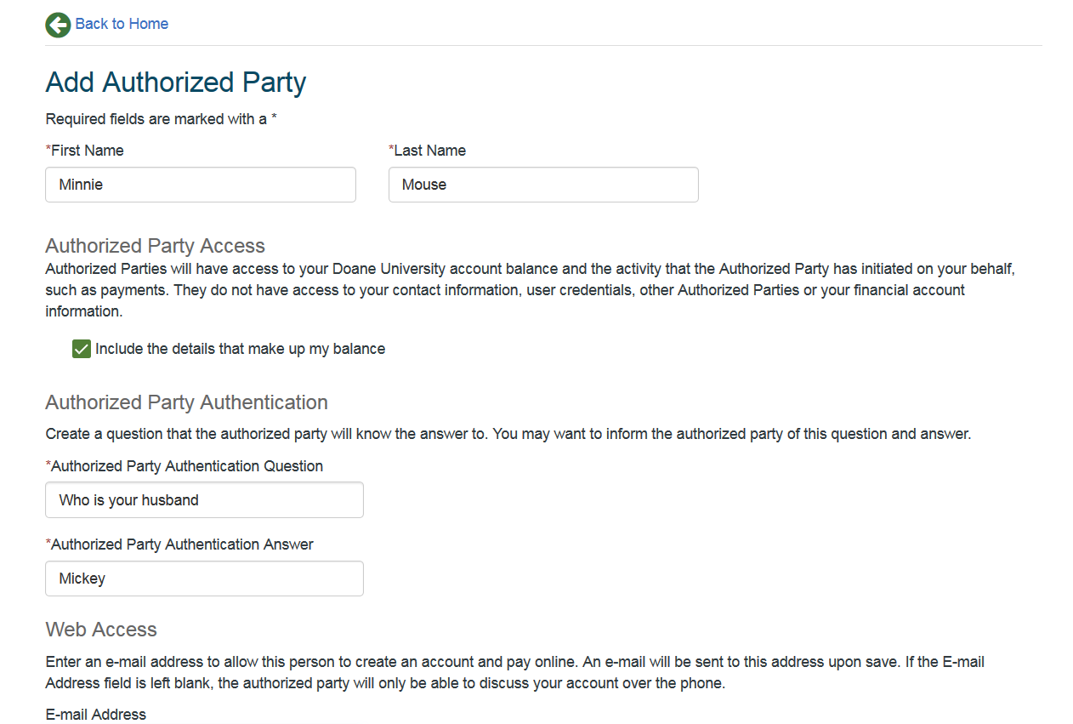

- If you entered information correctly and saved out, you will receive the following “success” note. All authorized parties will be added to your profile and can be edited at any time.

NOTE: Students and authorized payers have the option of signing up for text alerts for balance information and payment reminders.

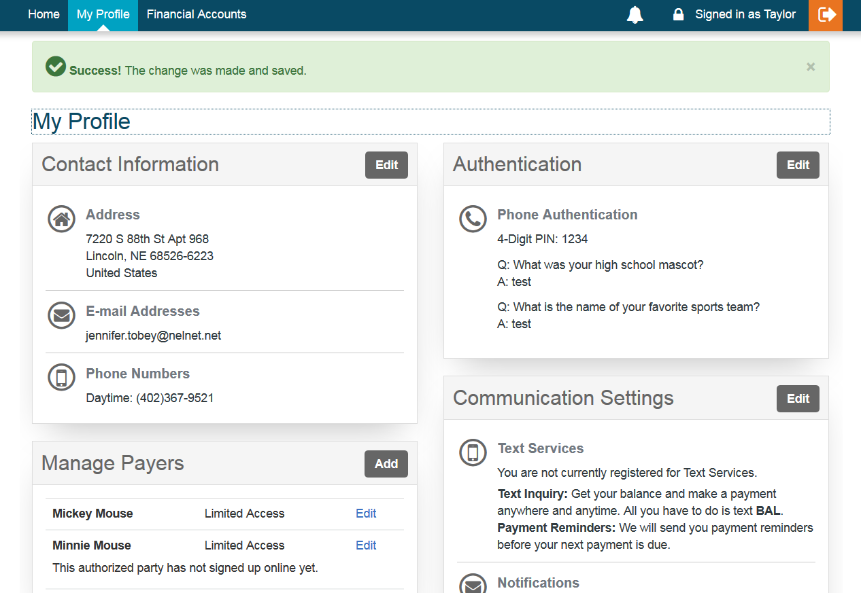

- Once the authorized payer is set up, they will receive an email with a link to create their own account.

